Fantastic fibre!

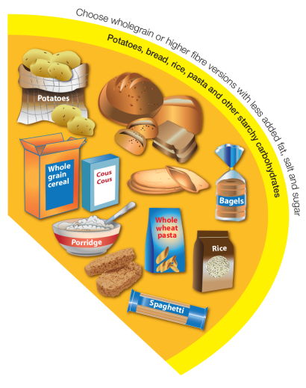
It is recommended that starchy food should make up just over a third of the food we eat and that we should choose higher-fibre, wholegrain varieties when we can.

Wholegrain food includes: wholemeal and wholegrain bread, pitta and chapatti, wholewheat pasta, brown rice, wholegrain breakfast cereals and whole oats. High fibre white versions of bread and pasta are also available. Remember that fruit, vegetables and beans/pulses also provide fibre.

Complete the diet diary below. Identify how you could increase your fibre intake.

 | What I ate | What changes could I make to increase my fibre intake?
Breakfast

Lunch

Evening meal

Snacks

Extension tasks

a) Explain the importance of fibre in the diet.

b) Use Explore Food to calculate the amount of fibre in the diet listed above.

