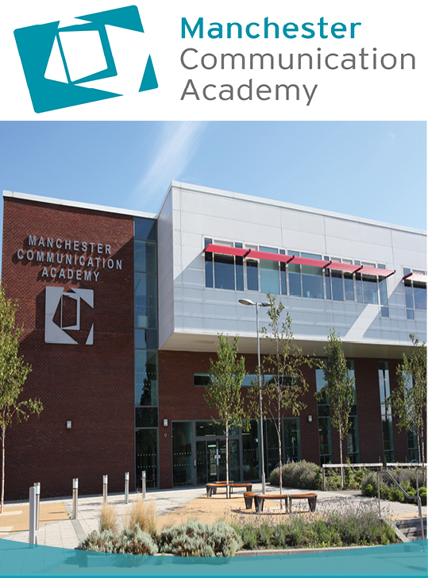

SMSC & BV Policy 2018 -19
Created: September 2018
Review: September 2019

Introduction
Spiritual, moral, social and cultural education helps children develop personal qualities which are valued in a civilised modern British society; for example, thoughtfulness, honesty, respect for difference, moral principles, independence, and self-respect. At Manchester Communication Academy we seek to teach these qualities across the curriculum and throughout academy life in the hope that these pupils go on to participate fully and contribute positively to life in modern Britain. It is linked closely to our Academy values and ethos.
Incorporated within SMSC are British Values, which are vital to the mission of MCA. The principles of democracy, the rule of law, individual liberty, and mutual respect and tolerance for those of different faiths and beliefs, are integral to the life of the Academy. These are not only included in the academic curriculum, but inform relationships between students and staff; are the basis of inter-staff cooperation; underlie home-school interaction and community participation; and are always salient in the formation of Academy policy and procedures.

Manchester Communication Academy Values:
- Trustworthy
- Helpful
- Inspiring
- Straightforward
- Heart

Defining spiritual, moral, social and cultural development
The spiritual development of pupils is shown by their:
- ability to be reflective about their own beliefs, religious or otherwise, that inform their perspective on life and their interest in and respect for different people’s faiths, feelings and values
- sense of enjoyment and fascination in learning about themselves, others and the world around them
- use of imagination and creativity in their learning
- willingness to reflect on their experiences.
The moral development of pupils is shown by their:
- ability to recognise the difference between right and wrong and to readily apply this understanding in their own lives, recognise legal boundaries and, in so doing, respect the civil and criminal law of England
- understanding of the consequences of their behaviour and actions
- interest in investigating and offering reasoned views about moral and ethical issues and ability to understand and appreciate the viewpoints of others on these issues.
The social development of pupils is shown by their:
- use of a range of social skills in different contexts, for example working and socialising with other pupils, including those from different religious, ethnic and socio-economic backgrounds
- willingness to participate in a variety of communities and social settings, including by volunteering, cooperating well with others and being able to resolve conflicts effectively
- acceptance and engagement with the fundamental British values of democracy, the rule of law, individual liberty and mutual respect and tolerance of those with different faiths and beliefs; they develop and demonstrate skills and attitudes that will allow them to participate fully in and contribute positively to life in modern Britain.
The cultural development of pupils is shown by their:
- understanding and appreciation of the wide range of cultural influences that have shaped their own heritage and those of others
- understanding and appreciation of the range of different cultures within school and further afield as an essential element of their preparation for life in modern Britain
- knowledge of Britain’s democratic parliamentary system and its central role in shaping our history and values, and in continuing to develop Britain
- willingness to participate in and respond positively to artistic, musical, sporting and cultural opportunities
- interest in exploring, improving understanding of and showing respect for different faiths and cultural diversity and the extent to which they understand, accept, respect and celebrate diversity, as shown by their tolerance and attitudes towards different religious, ethnic and socio- economic groups in the local, national and global communities.
(Ofsted – School Inspection Handbook – September 2018)

Where you can find SMSC in Manchester Communication Academy?

- The curriculum as a whole
- The Religious Education Curriculum
- The ‘Aspire’ Curriculum
- Form Time
- Assemblies
- Behaviour policy
- Extra-curricular activities
- Educational visits
- Pupil Voice (Student Council)
- Special days (fundraising, Student Performances and career days)
- Lunch time showcases

ROLE OF SENIOR LEADERS AND KEY STAFF
- To undertake audits across subject areas to determine SMSC provision and inform change.
- To promote and facilitate enrichment events in school through the inclusion of themes for the weekly focus in assemblies.
- To encourage staff and students to be involved in enrichment activities which are spiritually, morally, socially and culturally engaging both inside and outside the classroom.

How the curriculum contributes to SMSC & BV

English
- Developing confidence and expertise in language, which is an important aspect of individual and social identity.
- Enabling pupils to understand and engage with the feelings and values embodied in high quality poetry, fiction, drama, film and television.
- Developing pupils’ awareness of moral and social issues in fiction, journalism, magazines, radio, television and film.
- Helping pupils to understand how language changes over time, the influence on spoken and written language and social attitudes to the use of language.

Maths
- Through helping pupils obtain an insight into the infinite and through
- explaining the underlying mathematical principles behind natural forms and patterns.
- Helping pupils recognise how logical reasoning can be used to consider
- the consequences of particular decisions and choices and helping them learn the value of mathematical truth.
- Through helping pupils work together productively on complex mathematical tasks and helping them see that the result is often better than any of them could achieve separately.
- Through helping pupils appreciate that mathematical thought contributes to the development of our culture and is becoming increasingly central to our highly technological future, and through recognising that mathematicians from many cultures have contributed to the development of modern day mathematics.

Science
- Encouraging pupils to reflect on the wonder of the natural world.
- Awareness of the ways that Science and Technology can affect society and the environment.
- Consideration of the moral dilemmas that can result in scientific developments.
- Showing respect for differing opinions, for example on creation.
- Co-operation in practical activity.
- Raising awareness that scientific developments are the product of many.

ICT
- Preparing the pupils for the challenges of living and learning in a technologically enriched, increasingly interconnected world.
- Making clear the guidelines about the ethical use of the internet.
- Acknowledging advances in technology and appreciation for human achievement.

History
- Looking at the creation and evolution of British society.
- Enabling pupils to reflect on issues such as slavery, the Holocaust and Imperialism and to consider the moral and ethical issues.
- Showing an awareness of the moral implications of the actions of historical figures.
- To gain an understanding of different cultures.

Geography
- Opportunities for reflection on the creation of earth and its origins, future and diversity.
- Reflection on the fair distribution of the earth’s resources and issues surrounding climate change.
- A study of people and physical geography gives our pupils the chance to reflect on the social and cultural characteristics of society.

MFL

- Gain insights into the way of life, cultural traditions, and moral and social developments of other people.
- Social skills are developed through group work activities and communication exercises.
- Listening skills are improved through oral/aural work.

RE
- Pupils learn about beliefs, values and the concept of spirituality
- RE reflects on the significance of religious teachings in their own lives.
- Develops respect for the right of others to hold beliefs different from their own.
- Shows an understanding of the influence of religion on society.
- Fosters appreciation and understanding of different cultures, religions and traditions.

Art
- Art lessons develop pupils’ aesthetic appreciation.
- In turn, Art evokes feelings of ‘awe’ and ‘wonder’
- Giving pupils the chance to reflect on nature, their environment and surroundings.
- Studying artists with a spiritual or religious theme, issues raised by the artist which concerns ethical issues, such as War paintings.

Technology
- Reflecting on products and inventions, the diversity of materials and ways in which design can improve the quality of our lives.
- Awareness of the moral dilemmas created by technological advances.
- Awareness of how different cultures have contributed to technology.
- Opportunities to work as a team, recognising others strengths and sharing equipment.

Food Technology
- Giving the opportunity to examine cultural differences in food and diet.
- Reflecting on the social issues around food such as price and income.
- Acknowledging government guidelines for health and dietary requirements.
- Reflection on the moral issues concerning food production in third world countries.

Music
- Teaching that encourages pupils to be open to the music of other cultures.
- Discussing and reflecting upon a range of personal experiences and own performances and observed experiences like peer performances, trips and concerts.
- Looking at the way music can change moods and behaviour.
- Offer a range of high quality off-timetable music enrichment activities, for example access to individual instrumental/vocal/theory lessons with specialist peripatetic teachers.

PE
- Activities involving co-operation, teamwork, competition, rules, self-discipline and fair play.
- Exploring the sports and traditions of a variety of cultures.
- Individual activities that provide the opportunity for self-reflection, awareness and challenge.

Performing Arts
- An opportunity to work together and to negotiate and co-operate with each other.
- An opportunity to look at theatre from different cultures and religions.
- A cultural experience to enrich understanding of the performing arts in all its different forms.
- Opportunities to perform to others of different age groups, cultures and from different socioeconomic backgrounds.

DESIRED OUTCOMES
In addition to what Ofsted say about SMSC, at Manchester Communication Academy we aim to ensure all students experience and demonstrate the following, in the four SMSC areas:
Spiritual:
- Develop personality and character.
- Are self-aware and sensitive to the needs of others.
- Think deeply and reflect.
- Experience a sense of awe, wonder and mystery.
- Have clear personal values and are open to new ideas.
- Appreciate the importance of beliefs and values in human affairs.
- Have a clear sense of identity and belonging.
- Are able to express their feelings and emotions openly.
- Are creative, imaginative and perceptive.
- Are curious about the world around them.
- Respond with interest and develop from new experiences.
Moral:
- Take personal responsibility for their actions.
- Know the difference between right and wrong.
- Tell the truth and keep promises.
- Respect the rights and property of others.
- Exercise self-discipline.
- Understand the consequences of the actions of themselves and others.
- Help those less fortunate than themselves.
- Show a keen interest in ethical issues.
- Make reasoned and responsible responses to moral dilemmas.
- Reassess values in the light of experiences.
- Articulate their own attitudes and values.
- Help set guidelines to govern their own behaviour and behave consistently in accordance with these principles.
Social:
- Co-operate effectively with each other and participate successfully in the community as a whole.
- Develop the inter-personal skills necessary for successful relationships.
- Exercise responsibility.
- Participate successfully as a member of a group or team.
- Show respect for people, living things, property and the environment.
- Relate well to other people’s social skills and personal qualities.
- Accept others’ rights to hold different views / beliefs.
- Respect others’ needs and interests.
- Resolve conflicts intelligently and seek consensus.

- Challenge, when necessary and in appropriate ways, the values of a group or wider community.
- Reflect on their own contribution to society and to the world of work.
- Benefit from advice offered by those in authority or counselling roles.
- Appreciate the rights and responsibilities of individuals within the wider social setting.
- Understand how societies function and are organised in structures such as the family, the school and local and wider communities.
- Participate in activities relevant to the community.
- Understand the notion of interdependence in an increasingly complex society.
Cultural:
- Understand that cultures are always changing and equip students to cope with change.
- Have insight into their own and others’ cultures.
- Embrace and celebrate diversity.
- Challenge any form of prejudice.
- Recognise and understand their own cultural assumptions and values.
- Appreciate cultural diversity and accord dignity and respect to other people’s values and beliefs.
- Are open to new ideas and demonstrate a willingness to modify cultural values in the light of experience.
- Develop an ability to use language and understand images / icons – for example, in music, art, literature – which have significance and meaning in a cultural context.
- Are willing to participate in, and respond to, artistic and cultural enterprises.
- Experience a sense of personal enrichment through encounters with cultural media and traditions from a range of cultures.
- Have a regard for the heights of human achievement in all cultures and societies.
- Appreciate the diversity and interdependence.

