Energy worksheet

- Fill in the names of the macronutrients for each of the recommended energy
intakes.
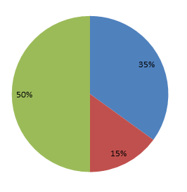

- List the following in order of least to most energy used.
- Explain why the body needs energy.
______________________________________________________________________

______________________________________________________________________

______________________________________________________________________

______________________________________________________________________

- List 5 reasons why someone’s energy needs might change.

__________________ __________________ _________________

__________________ __________________

- How many kcals/gram do each of the following provide?
Carbohydrate _____________________

Fat _____________________

Protein _____________________

Alcohol _____________________

- What is someone’s total energy expenditure if their BMR = 1700 and
their PAL = 1.6?
_______________________

- Name 3 factors that would affect someone’s BMR?
______________________

______________________

______________________

